**DAILY ONLINE ACTIVITIES SUMMARY**

|  |  |  |  |  |  |  |  |
| --- | --- | --- | --- | --- | --- | --- | --- |
| **Date:** | **20\05\2020** | | | | **Name:** | **AMBIKA - V** | |
| **Sem & Sec** | **4th SEM SECTION 'A'** | | | | **USN:** | **4AL18CS005** | |
| **Online Test Summary** | | | | | | | |
| **Subject** | | **Object Oriented Concepts(18CS43)** | | | | | |
| **Max. Marks** | | **30** | | **Score** | | **19** | |
| **Certification Course Summary** | | | | | | | |
| **Course** | **CLOUD FOUNDATION** | | | | | | |
| **Certificate Provider** | | | **GREAT LEARNING ACADEMY** | **Duration** | | | **3.5hrs** |
| **Coding Challenges** | | | | | | | |
| **Problem statement 1:** Given an array a[] of size n which contains elements from 0 to n-1, write a program printDuplicates which prints the duplicate elements of the given array. If no duplicate element is found print -1.(2) Write a C or Java program to implement FCFS and SJF process scheduling. | | | | | | | |
| **Status: Executed** | | | | | | | |
| **Uploaded the report in Github** | | | | **yes** | | | |
| **If yes Repository name** | | | | **https://github.com/ambika0202/lockdown-coding-** | | | |
| **Uploaded the report in slack** | | | | **Yes** | | | |

**Online Test Details:** Ooc test start at 9:30 and finished at 10:15. 20 questions of one marks and 10 questions of programmatical questions.The score that I received was 19/30.

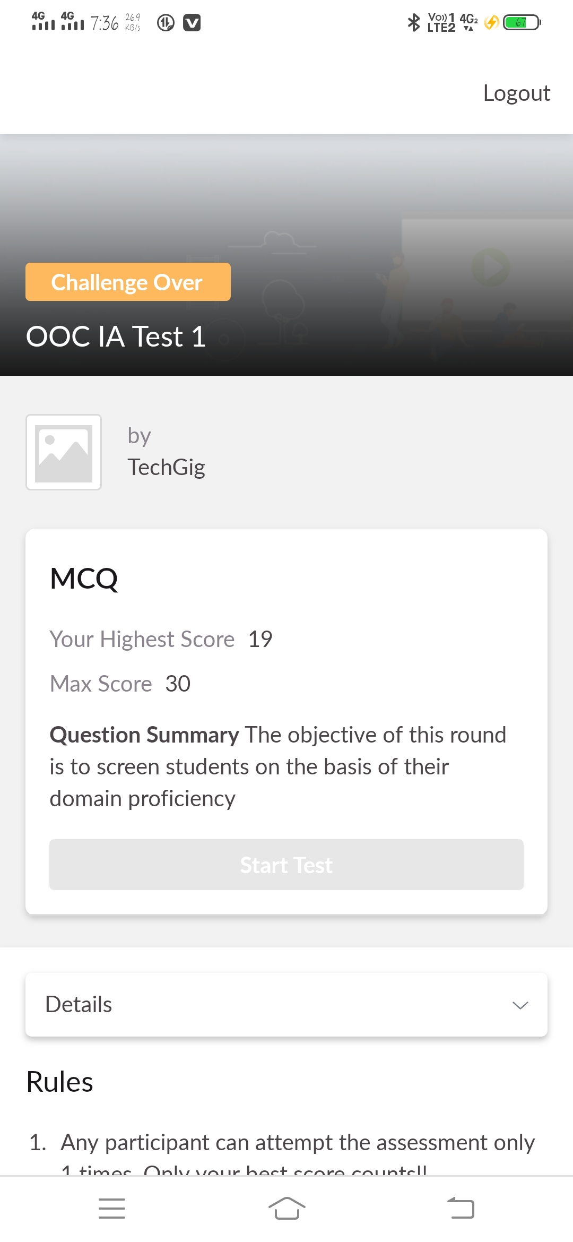

**CERTIFICATIONCOURSEDETAILS**

Today i started new course of cloud foundation of pricing and scaling models and introduction to virtualization.

**Pricing and scaling Models**

The price in the model is based on the subscription period this model is static, in this model the cloud user might sometimes overpay or underpay.. It is a dynamic model because the price depends on competition.

Scaling is defined as the ability for an IT resource to handle growing or decreasing demands in a capable manner. It is one of the most popular and beneficial features of cloud computing, as businesses can scale up or down to meet demands based on season, projects, growth and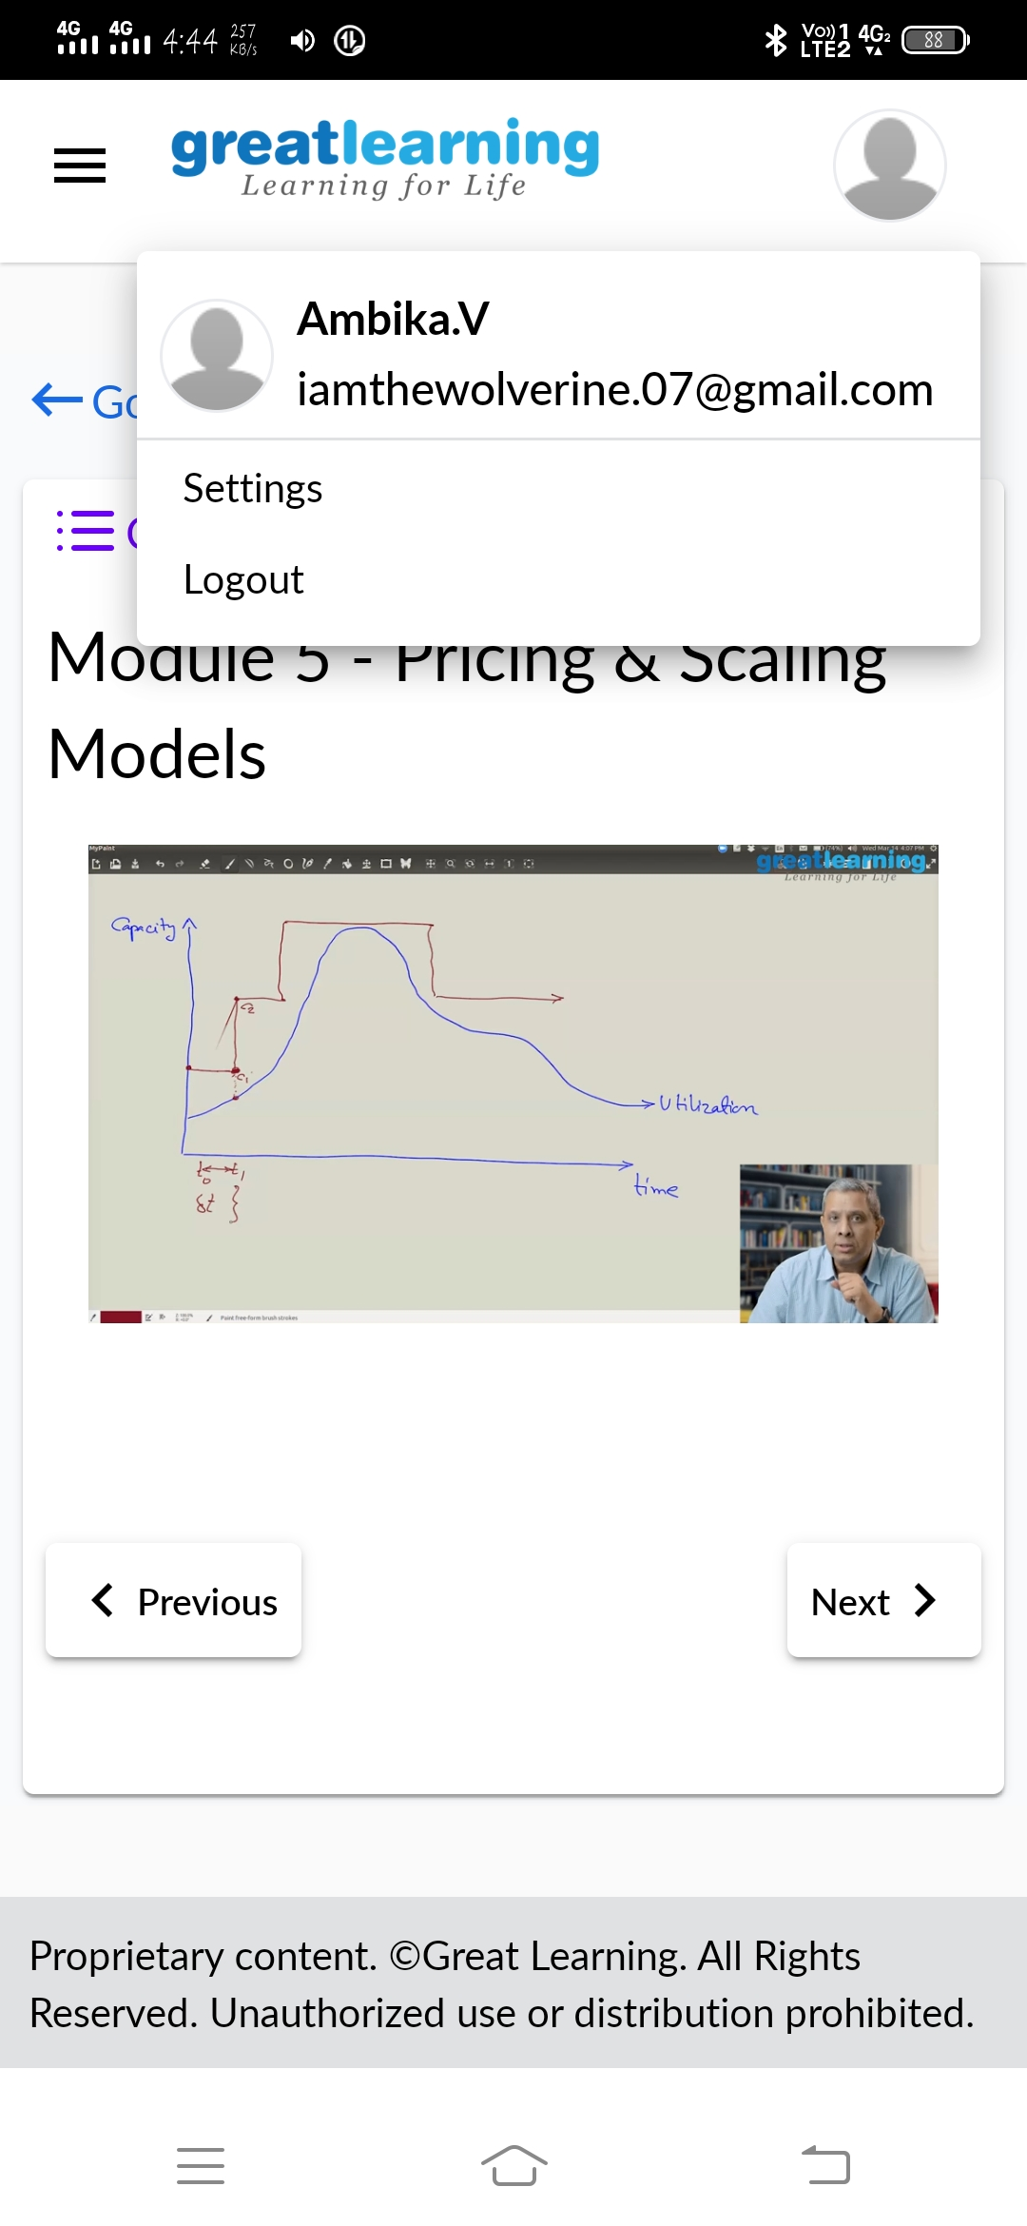 more.

**2.Introduction to virtualization**

Virtualization is the creation of a simulated version of something else. Computers can create virtual networks, storage, disk drives, operating systems, and other forms of hardware. Physical machines are referred to as "Host" machines while simulated machines are referred to as virtual machines.

Three Kinds of Server Virtualization. There are three ways to create virtual servers: full virtualization, para-virtualization and OS-level virtualization. They all share a few common traits. The physical server is called the host.

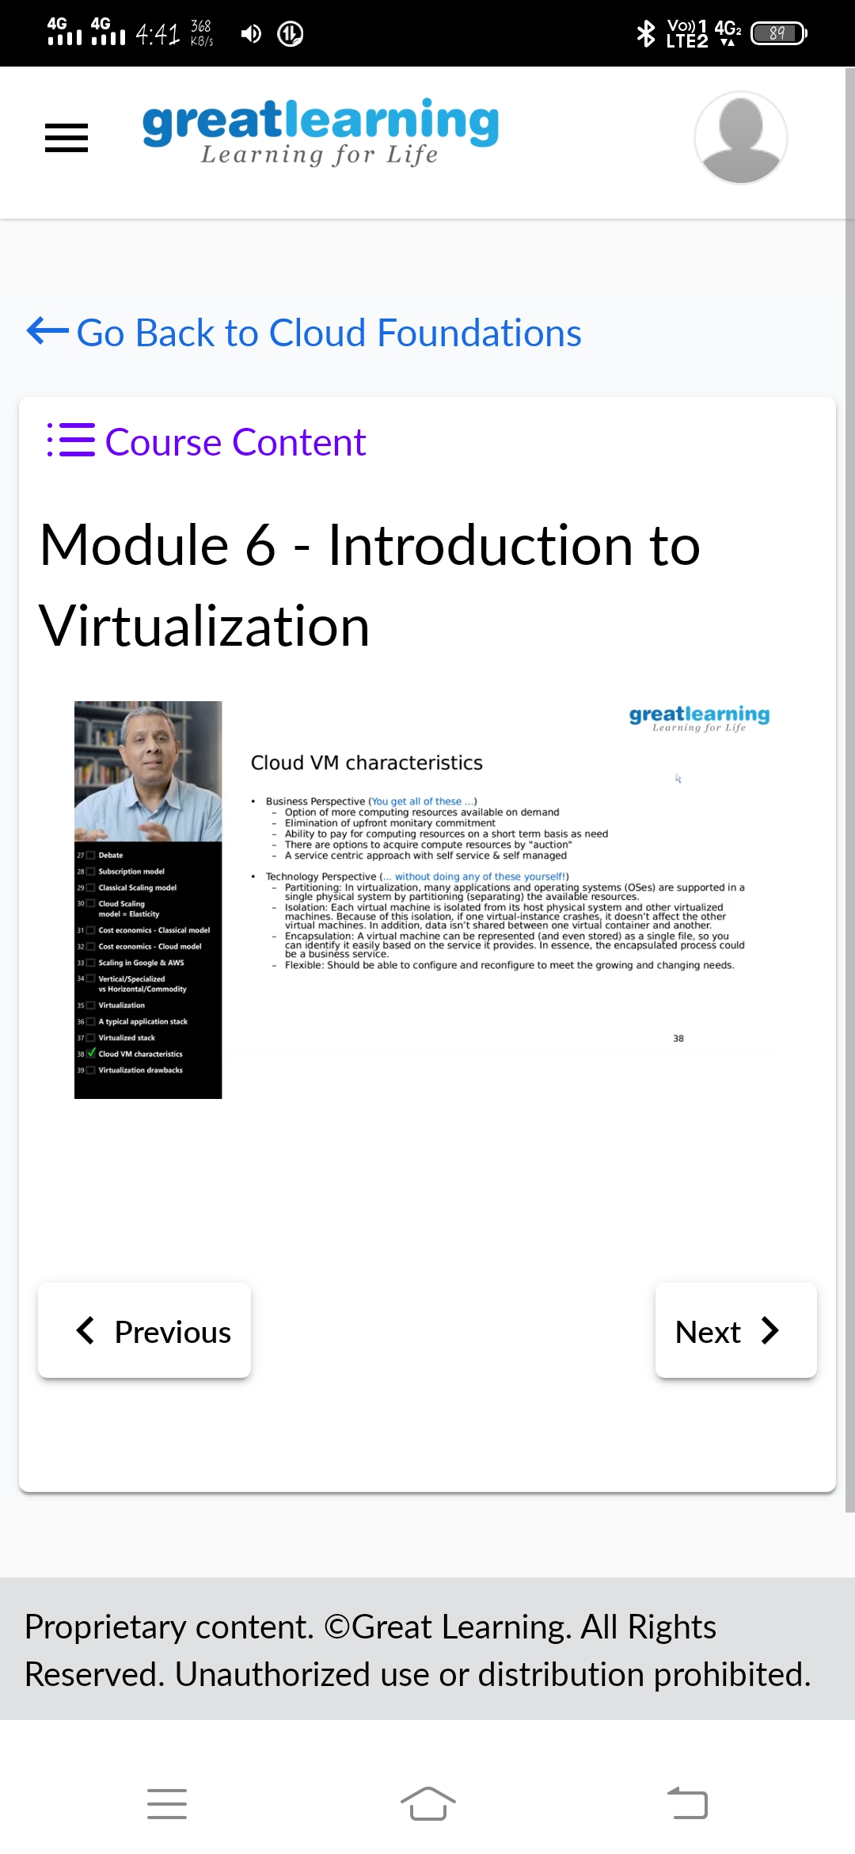

**Coding Challenges Details:**

**Problem statement 1:** Given an array a[] of size n which contains elements from 0 to n-1, write a program printDuplicates which prints the duplicate elements of the given array. If no duplicate element is found print -1.

Input: The first line of input must contains an integer n which denotes number of elements of Array. Second line contains n space separated integers denoting elements of array a[].

Output: Print the duplicate elements from the given array.

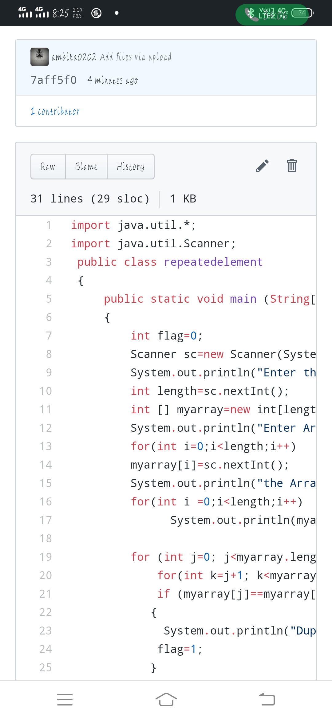

**Problem statement 2:**

Write a C or Java program to implement FCFS and SJF process scheduling.

Input: Processes with burst time

Out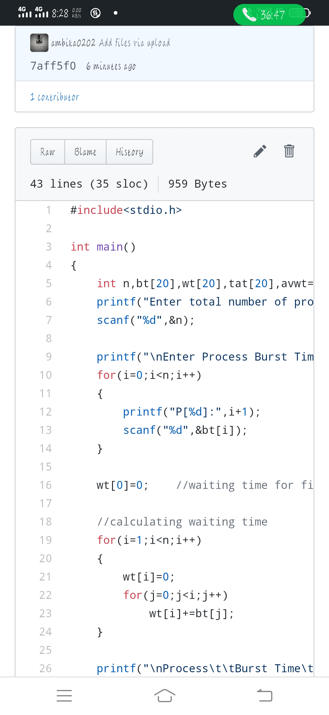put: Process being scheduled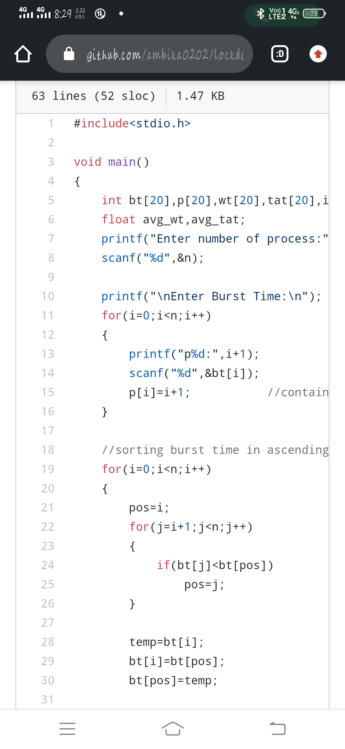

**Problem statement 3**

Write a c program to reverse a sll

Test Case 1:

If a linked listis: 1 → 2 → 3 → 4 → 5 → 6 → 7 → 8

The value of size k is 2

Then the linked list looks like: 2 → 1 → 4 → 3 → 6 → 5 → 8 → 7

Test Case 2:

If a linked listis: 1 → 2 → 3 → 4 → 5 → 6 → 7 → 8

The value of size k is 3

Then the linked l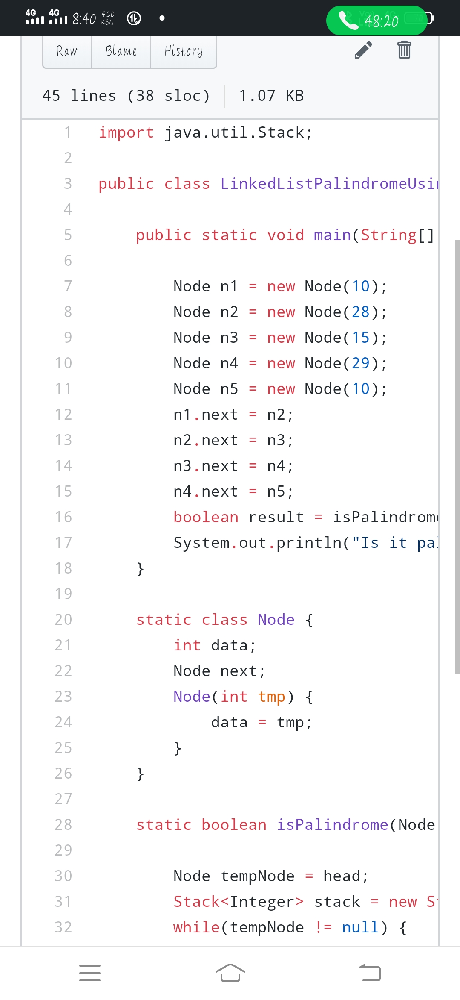ist looks like: 3 → 2 → 1 → 6 → 5 → 4 → 8 → 7